Unit 13:

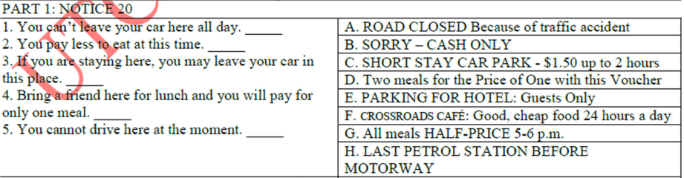

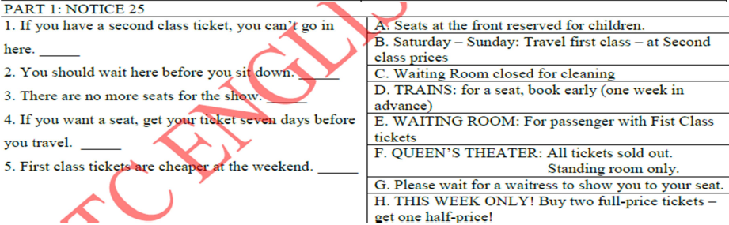

In advance: truoc

Thank you in advance

Pay in advance

|  |  |
| --- | --- |
|  | Suitcase – clothes |

|  |  |
| --- | --- |
|  | 51. Brazilian  52. receptionist  53. 26 Park Road  54. Learn English  55. 2 months |

Listening Test 2:

PART 1

|  |  |
| --- | --- |
| Eyes – nose – a dress    Geography – music – maths    Paint the wall – clean the window – clean the floor  Tomatoes – fish - cheese        16. 13  17. 11th  18. family  19. 690  20. Farley |  |

PART II: Cap so sanh tuyet doi cua tinh tu

* Dung de so sanh 3 vat/ nguoi tro len.

Cong thuc: 3 dang cong thuc

1. Short adjective: (long, happy, new…)

S be the short adj+est (n) in (place)

of/ among (people)

vd: Hung is the tallest student in the class.

Vd2: This is the cheapest car in the garage.

*bien doi tt ngan => cap ss tuyet doi:

Short => the shortest

Big=> the biggest

Large => the largest

New => the newest

Happy => the happiest

1. Long adjective:

S be the most / least long adj (n) in/of/among…

VD: This is the most expensive **hotel** in the town.

Vd2: This hotel is the most expensive in the town.

Apples are the least popular in Vietnam.

1. Dang bat quy tac:

S be the (BQT) (n) in/of/among…

BQT:

**Good/ well => the best**

**Bad/ badly=> the worst**

Little=> the least

Vd: My test was the worst in my class.

This is the best food in the restaurant.

CHu y: ta co the dung cap so sanh tuyet doi trong cau binh pham di voi tu ever o hientai hoan thanh.

Vd: This is the most famous person that I have ever met.

**Huong dan phan viet so 7: (10/100)**

* **Dien 1 tu duy nhat vao moi cho trong (10 cho trong)**
* **Hoan thanh 1 buc thu (giong phan 9) – 2 ng viet cho nhau (I/ you)**
* **Ket thu:**

**I hope to see you soon.**

**Write to me soon.**

**I look forward to hearing from you as soon as possible.**

**\*chu y: Cac tu can dien vao cho trong thuong la nhung tu mang y nghia ngu phap ( gioi tu, ttsh, dt st, dt nx, dong tu to be, gioi tu chi dia diem hoac thoi gian…chu y den thi de chon tu cho dung)**

**Nhin vao cho trong truoc, tu dung truoc va tu dung sau => co the dua ra dap an.**

**A lot …of chocolate** 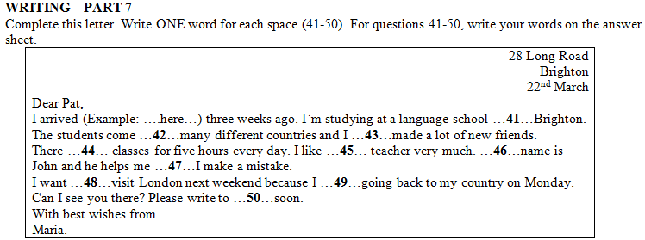

**41. At di voi dia diem nho, hep – in**

**42. from 43. Have 44. Are 45. My 46. His 47. When 48. to 49. Am 50. Me**



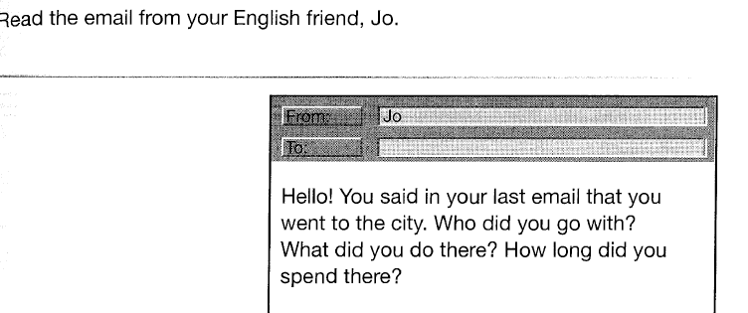

Dear Jo,

Yesterday I went to the city with my best friend. I attended a festival in the city. I stayed there for 2 hours. I hope to see you soon.

Best wishes,

Name

**Homework 4 (65), 6 (66), 7(67), 8 (68)**

